Construction Project Management System
Final Report

Course: DPR400210 – Database Programming with Oracle Database
Project Title: Construction Project Management System
Student ID: 32407
Student Name: MOHANAD MIRGHANI ALI
Instructor: ERIC Maniraguha
Academic Year: 2025–2026

Table of Contents
- Introduction
- Problem Statement
- Project Objectives
- Target Users
- Expected Benefits
- Business Process
- ER Diagram
- Database Design
- SQL Implementation
- PL/SQL Programming
- Triggers and Auditing
- Security Implementation
- Innovation (Power BI Dashboard)
- Testing and Results
- Conclusion
- References

1. Introduction
The Construction Project Management System is an Oracle Database application developed to improve the management of construction projects. The system stores and manages information related to clients, projects, engineers, workers, suppliers, materials, equipment, and payments.
The project was developed using Oracle SQL and PL/SQL to demonstrate database programming concepts such as tables, constraints, procedures, functions, packages, cursors, triggers, auditing, and security implementation. Additionally, Microsoft Power BI was used to create an analytical dashboard for project reporting and visualization, fulfilling the innovation requirement of the capstone project.

2. Problem Statement
Many construction companies still rely on manual methods to manage projects, workers, materials, and payments. These manual processes often lead to data loss, delays, inconsistent records, and difficulties in monitoring project progress.
The Construction Project Management System was developed to provide a centralized Oracle database that stores all project information securely, improves data accuracy, simplifies project tracking, and supports better decision-making for construction companies.
3. Project Objectives
The main objectives of this project are:
- To manage construction projects efficiently.
- To store information about clients, engineers, workers, suppliers, materials, and equipment.
- To monitor project progress and payment transactions.
- To improve data integrity using Oracle constraints.
- To automate database operations using PL/SQL.
- To implement auditing and database security.
- To provide analytical reports through Power BI.
- 4. Target Users
The system is designed for the following users:
- Project Manager
- Site Engineer
- Accountant
- System Administrator
5. Expected Benefits
The expected benefits include:
- Better organization of construction projects.
- Faster retrieval of project information.
- Reduced data redundancy.
- Improved project monitoring.
- Secure storage of project records.
- Better management of payments and construction resources.
- Support for management decision-making through dashboards.

6. Business Process
The business process begins when a client submits a request for a construction project. The project manager creates the project record in the system and assigns engineers and workers. Materials and equipment are allocated to the project, while project progress is continuously updated. Payments are recorded during project execution. Once construction activities are completed, the project status is updated, and a final report is generated.
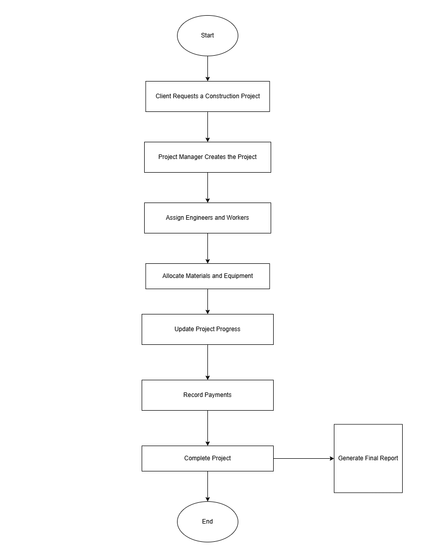

7. ER Diagram
The system database consists of several related entities that support construction project management.
Main entities include:
- Client
- Project
- Engineer
- Worker
- Supplier
- Material
- Equipment
- Payment
Relationships between these entities are implemented using Primary Keys and Foreign Keys to maintain referential integrity.
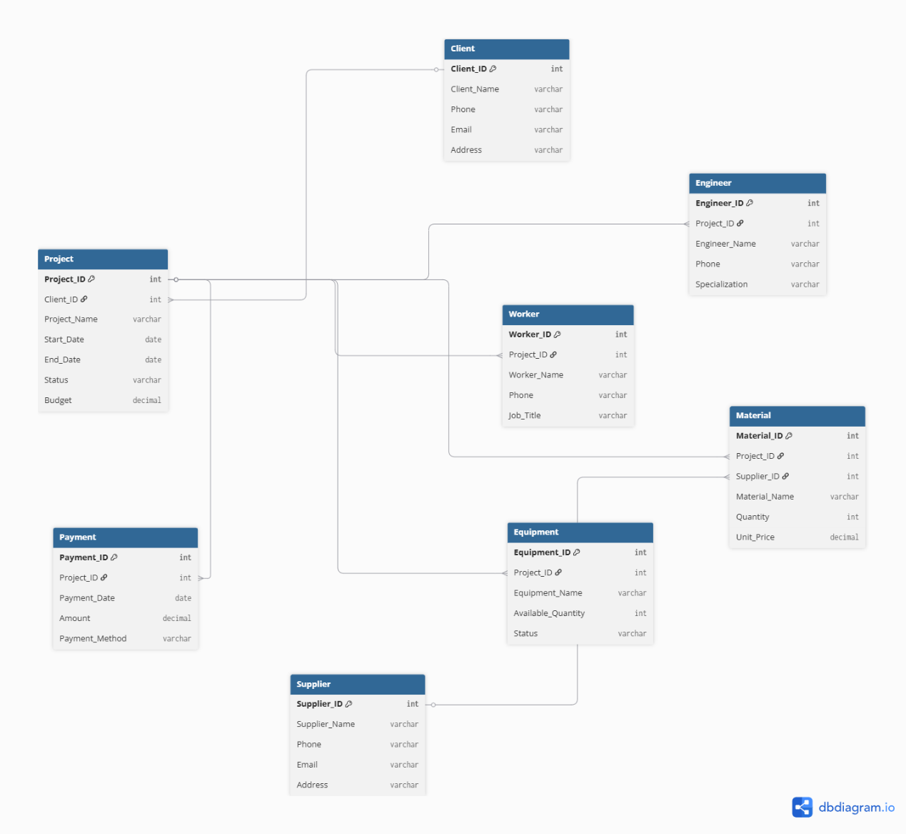
8. Database Design
The Construction Project Management System was designed using the relational database model. The database was normalized up to Third Normal Form (3NF) to eliminate redundancy and ensure data consistency. Each table has a primary key, while relationships between tables are maintained using foreign keys.
The main tables included in the system are:
Table | Description
CLIENT | Stores client information
PROJECT | Stores construction project information
ENGINEER | Stores engineers assigned to projects
WORKER | Stores workers assigned to projects
SUPPLIER | Stores supplier information
MATERIAL | Stores construction materials
EQUIPMENT | Stores equipment used in projects
PAYMENT | Stores project payment transactions
PUBLIC_HOLIDAYS | Stores’ public holiday dates used by the security trigger
AUDIT_LOG | Records database activities for auditing purposes

9. Table Implementation
The database tables were created using Oracle SQL. Each table includes appropriate constraints to maintain data integrity.
The implemented constraints include:
- Primary Key (PK)
- Foreign Key (FK)
- NOT NULL
- UNIQUE
- CHECK Constraints
These constraints prevent invalid data from being inserted into the database and ensure consistency between related tables.
The following tables were successfully created:
Client Table
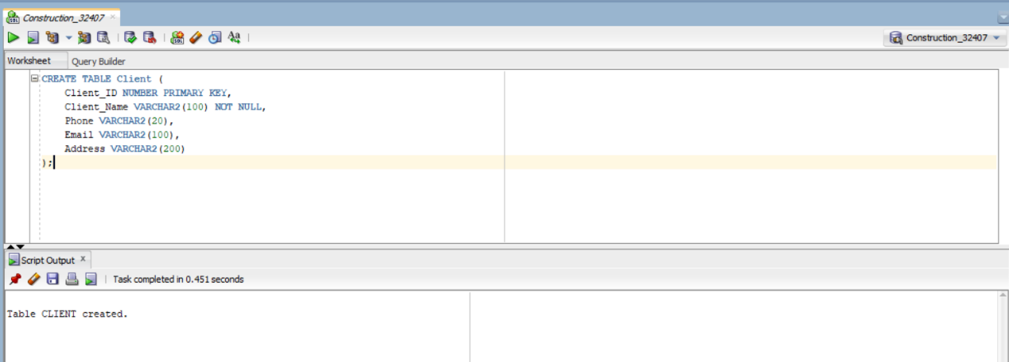
Project Table
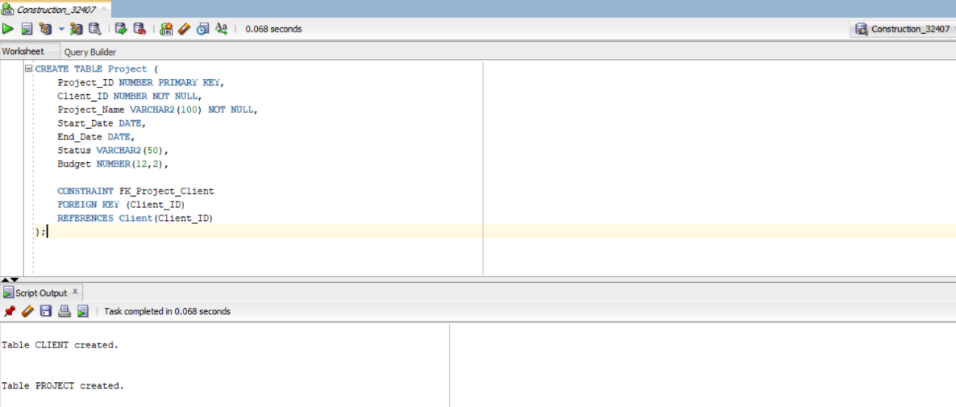

Engineer Table
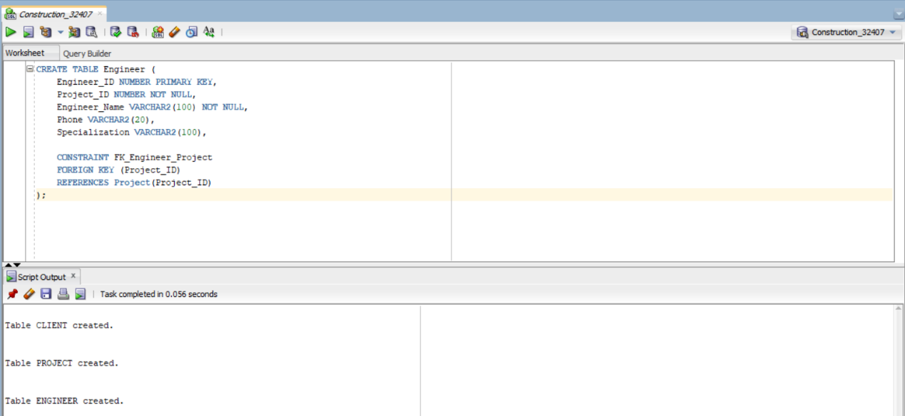

Worker Table
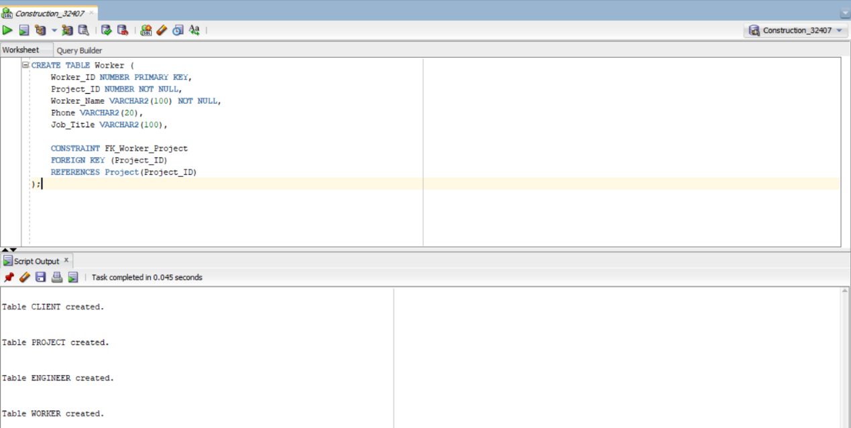
Supplier Table
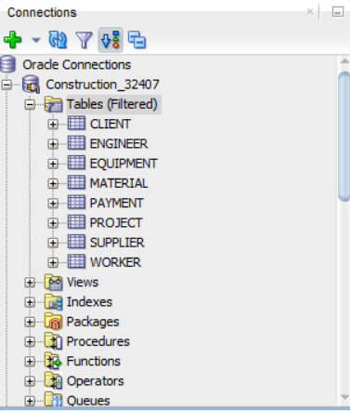

10. Sample Data
After creating the database tables, meaningful sample data were inserted to simulate a real construction company environment. The inserted records include clients, projects, engineers, workers, suppliers, materials, equipment, and payment transactions.
The sample data was used to test SQL queries, PL/SQL programs, and reporting functions.
Client Data
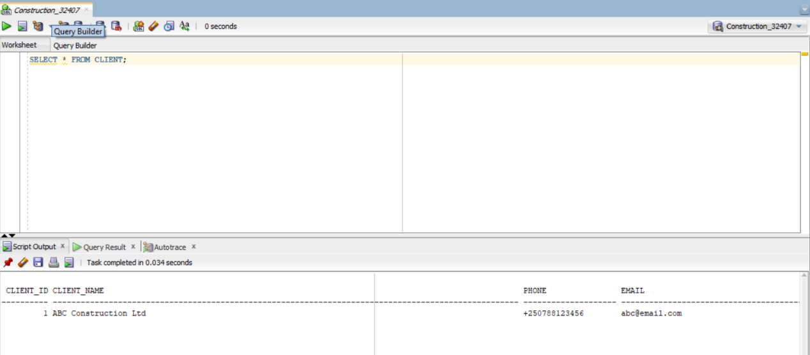
Supplier Data
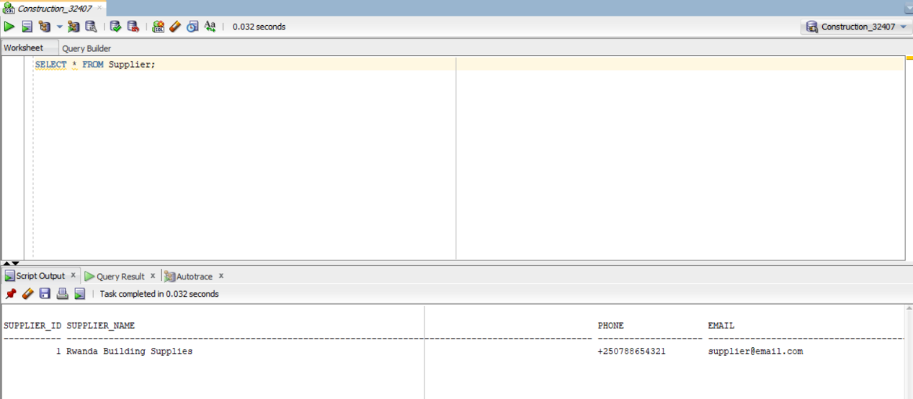
Project Data
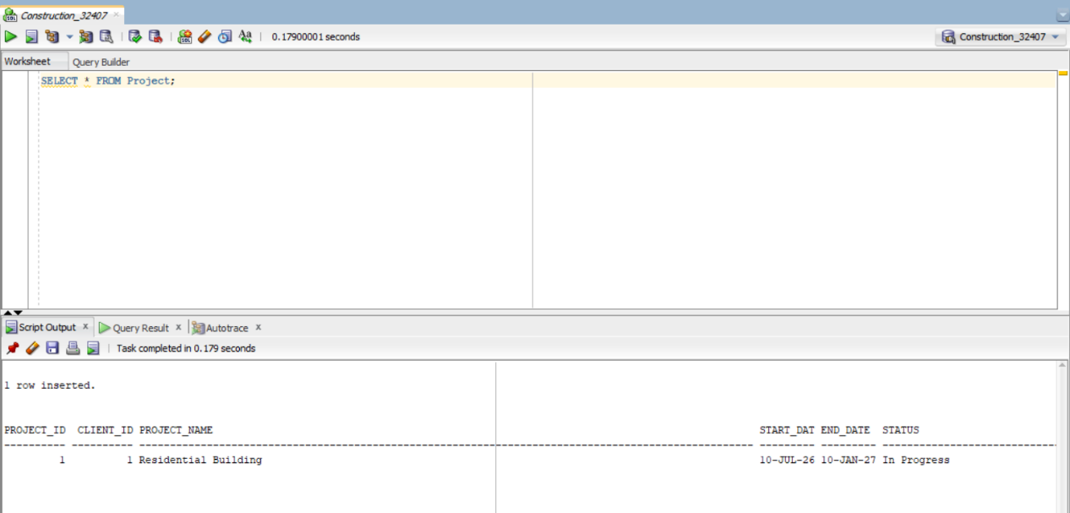
Engineer Data
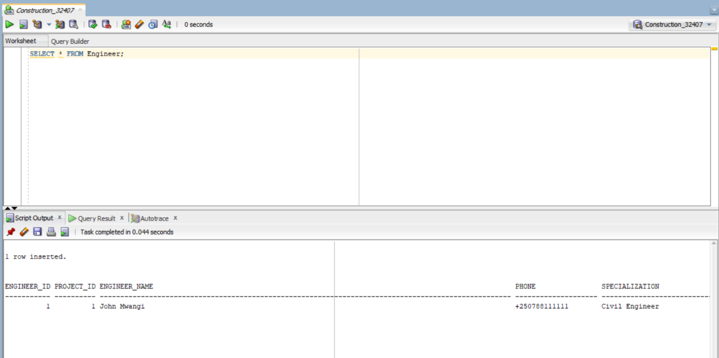
Worker Data
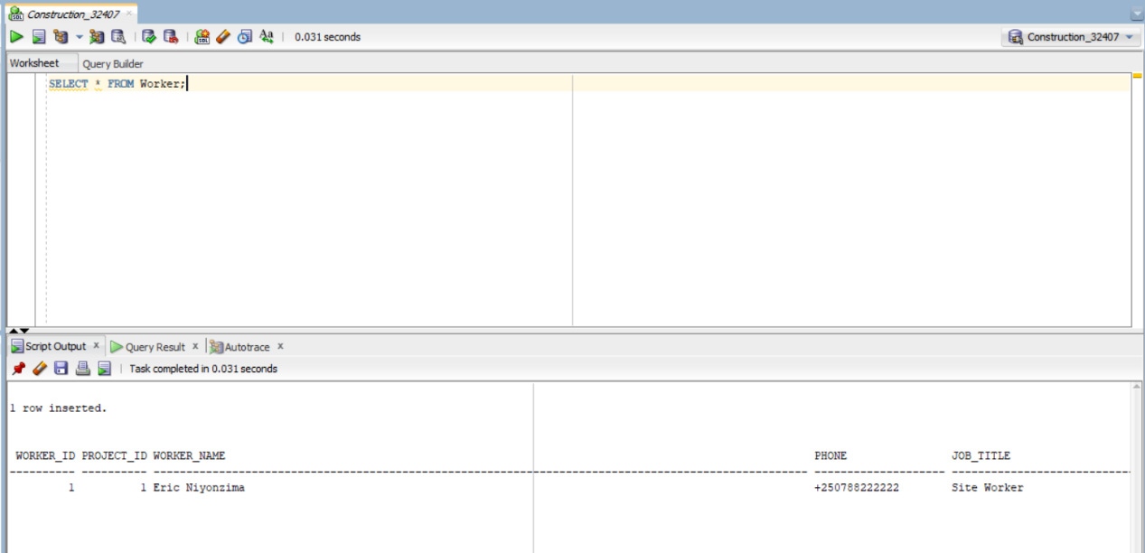

Material Data
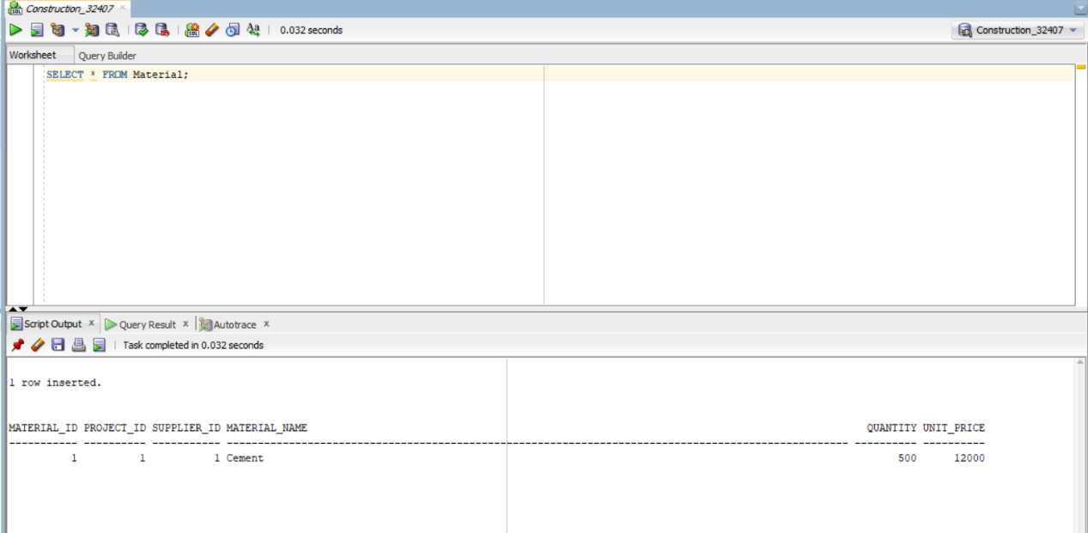
Equipment Data
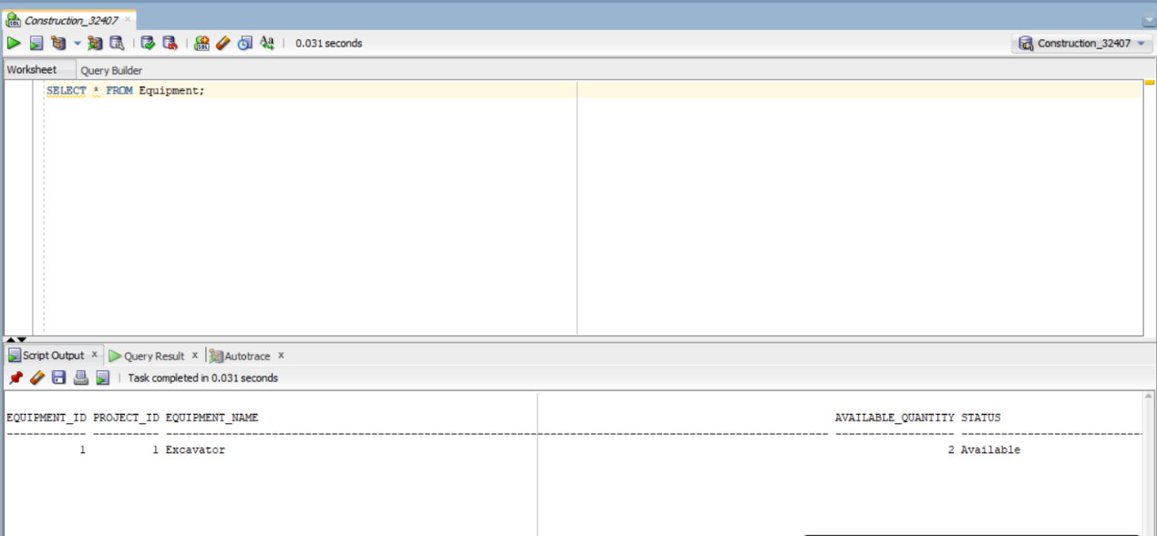

Payment Data
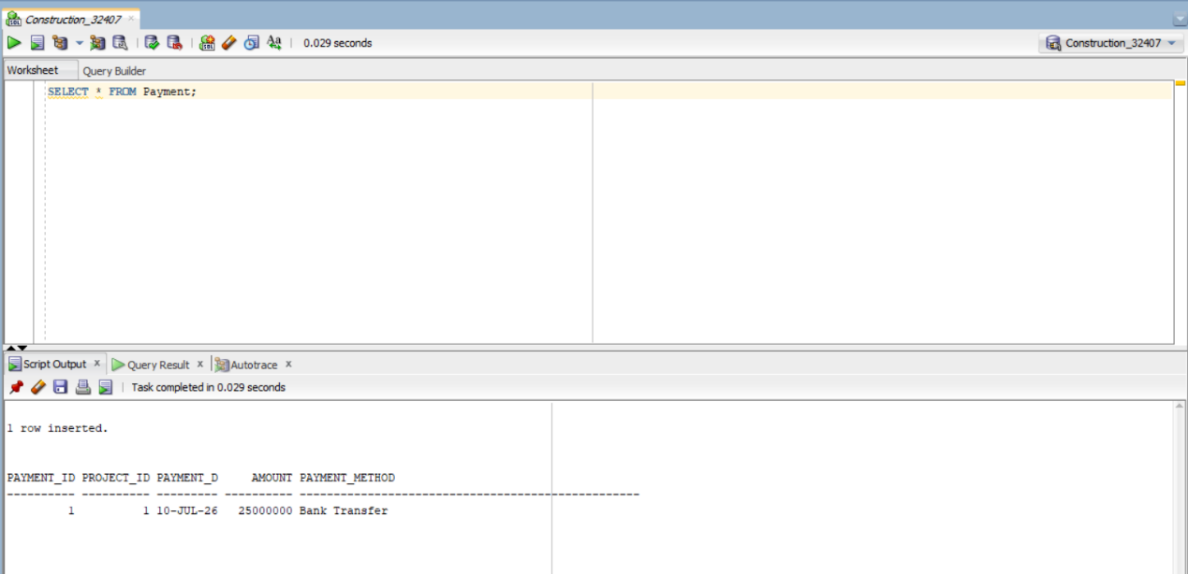

11. SQL Queries
Several SQL queries were implemented to retrieve useful information from the database. These queries help users monitor construction projects and generate reports.
The implemented SQL statements include filtering, joining tables, and aggregate functions.
Query 1 – Materials with Suppliers
This query displays all materials together with their corresponding suppliers.
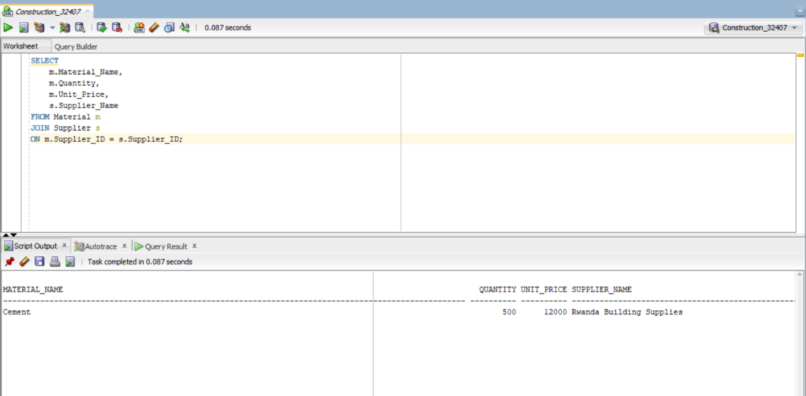

Query 2 – Total Payments
This query calculates the total payments received for each project.
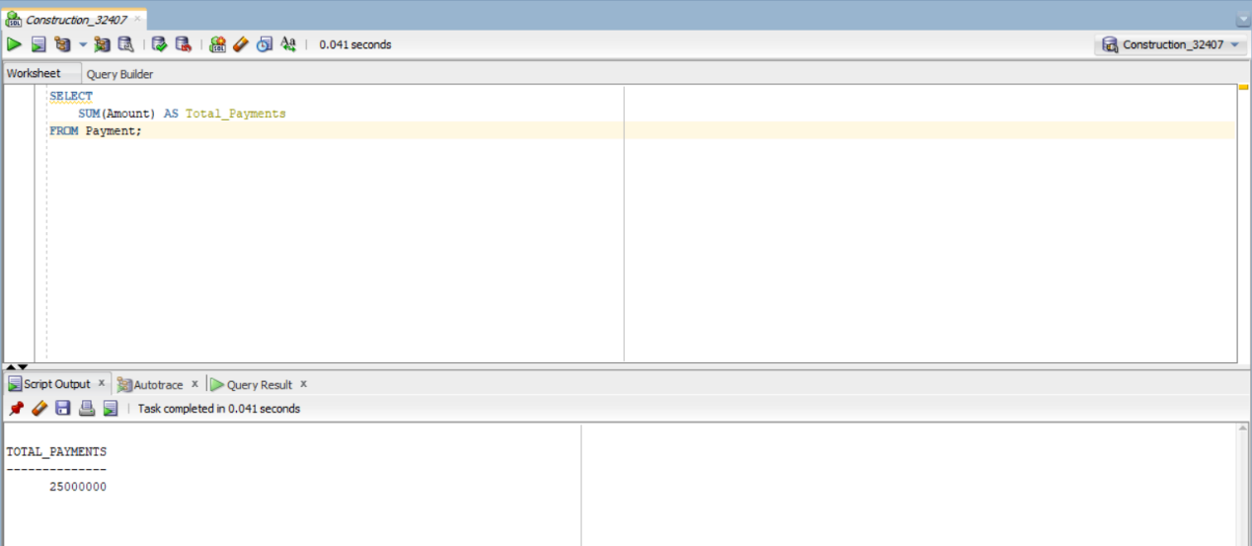
Query 3 – Projects in Progress
This query displays all projects whose status is In Progress.
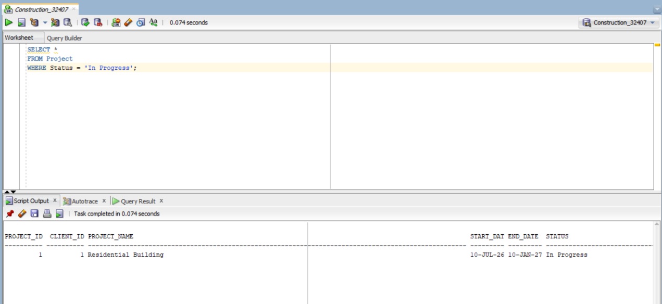

12. PL/SQL Programming
Oracle PL/SQL was used to automate database operations and improve system functionality. The project includes procedures, functions, packages, cursors, and exception handling.

12.1 Stored Procedure
A parameterized stored procedure named Add_Project was developed to insert new construction projects into the PROJECT table.
The procedure accepts project details as parameters and automatically inserts a new record into the database. This minimizes manual work and improves data consistency.
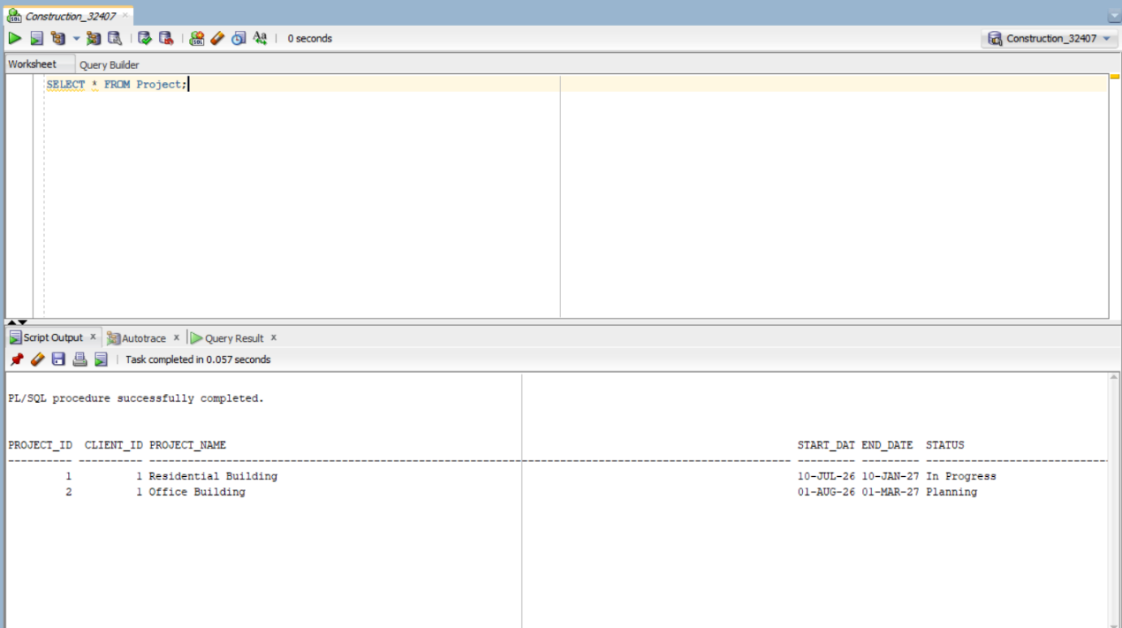
12.2 Function
A PL/SQL function named Get_Total_Payments was created to calculate the total payments made for a specific construction project.
The function returns the total payment amount using the SUM aggregate function.
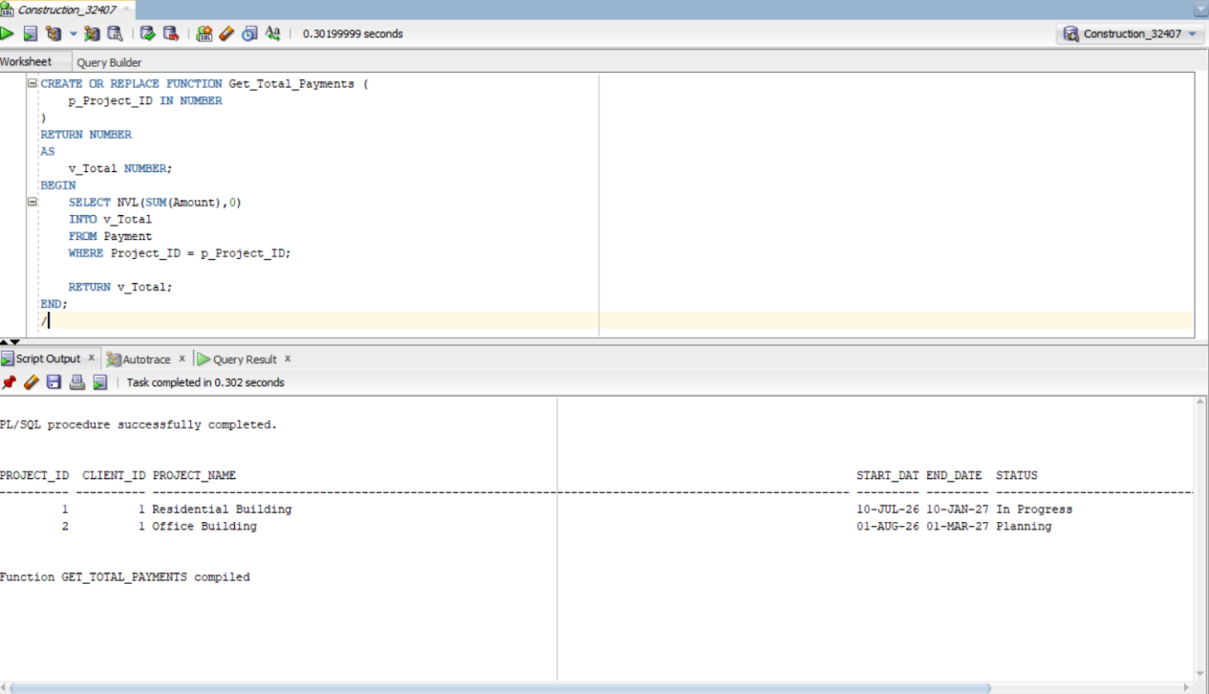
The function was tested successfully and returned the correct payment amount.
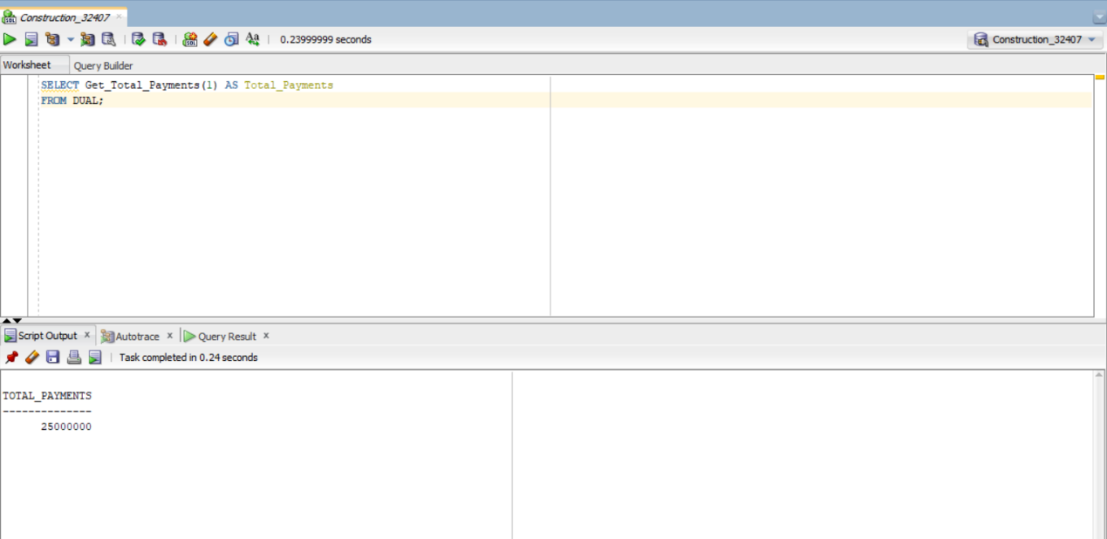
12.3 Package
To improve code organization and reusability, a PL/SQL package named PROJECT_PACKAGE was created.
The package contains:
- Procedure: Add_Project
- Function: Get_Total_Payments
The package specification declares the procedures and functions, while the package body implements their logic.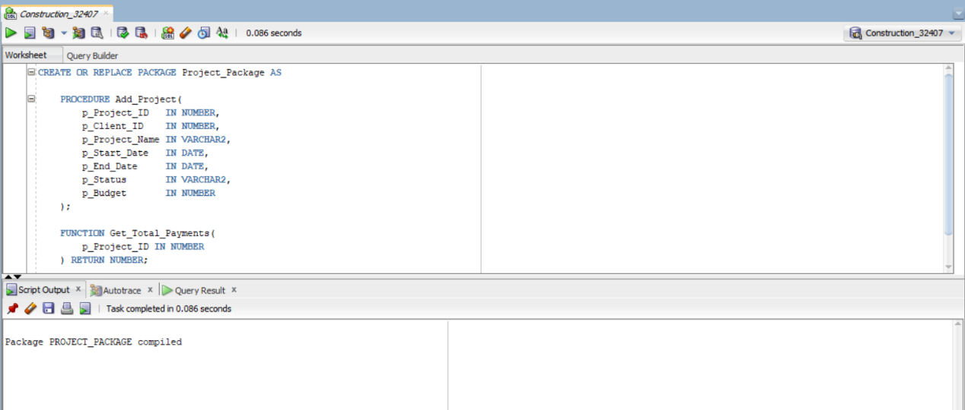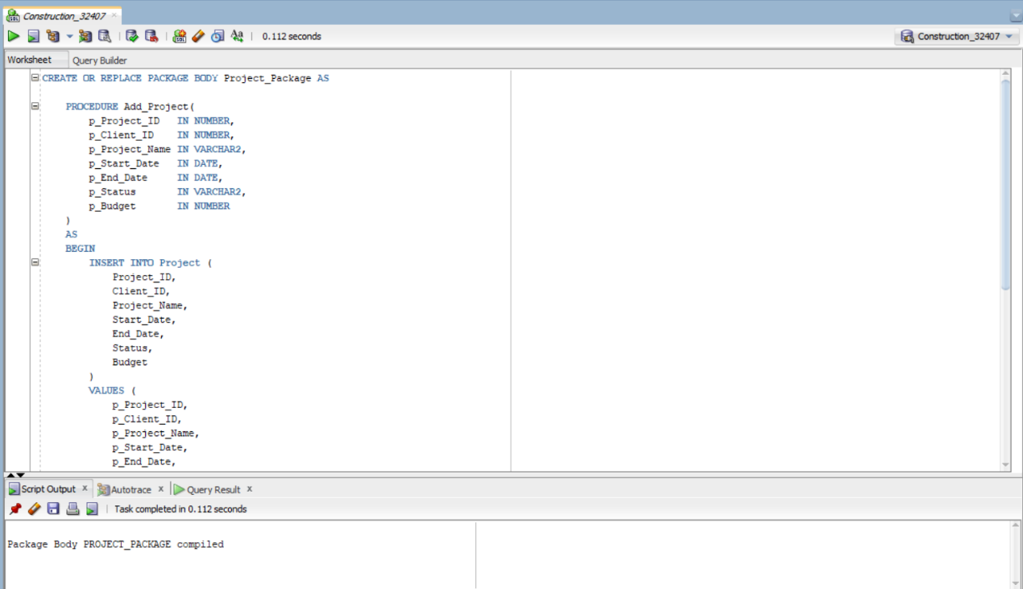

12.4 Cursor
A cursor was implemented to retrieve project information one record at a time.
The cursor demonstrates how Oracle PL/SQL processes multiple rows sequentially and displays project details using DBMS_OUTPUT.
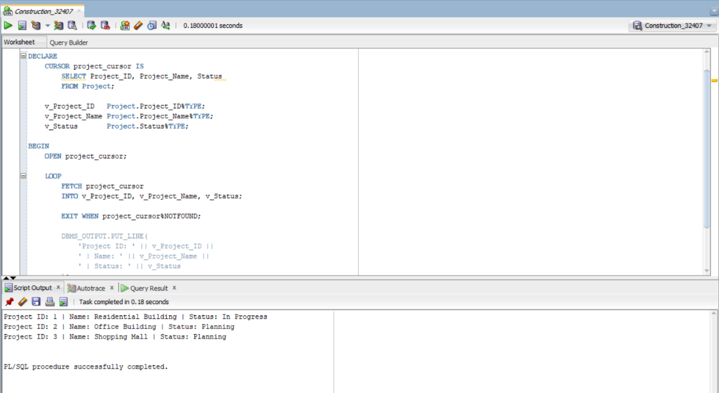
12.5 Exception Handling
Exception handling was implemented to prevent unexpected runtime errors and improve system reliability.
The procedure handles invalid operations gracefully and provides meaningful error messages to the user.
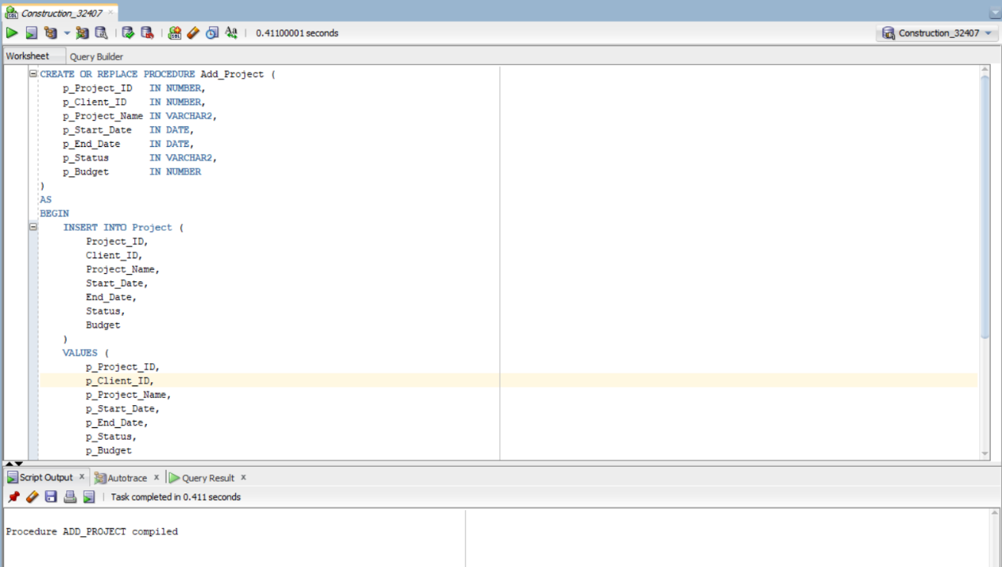
13. Advanced Database Programming
The project implements advanced Oracle database programming concepts using triggers, auditing, and security mechanisms.

13.1 Public Holidays Table
A reference table named PUBLIC_HOLIDAYS was created to store official public holidays.
The security trigger uses this table to prevent unauthorized database modifications during restricted days.
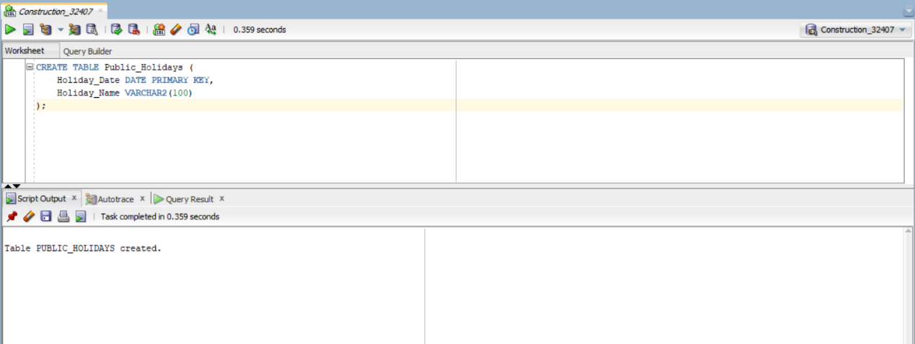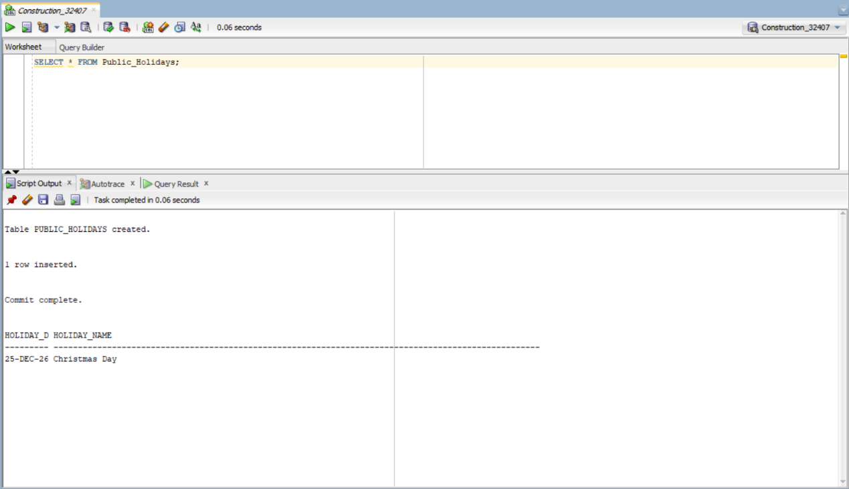
13.2 Audit System
An audit table named AUDIT_LOG was created to record database activities.
The audit trigger automatically stores information about every INSERT operation performed on the PROJECT table.
Recorded information includes:
- Username
- Action Type
- Table Name
- Action Date
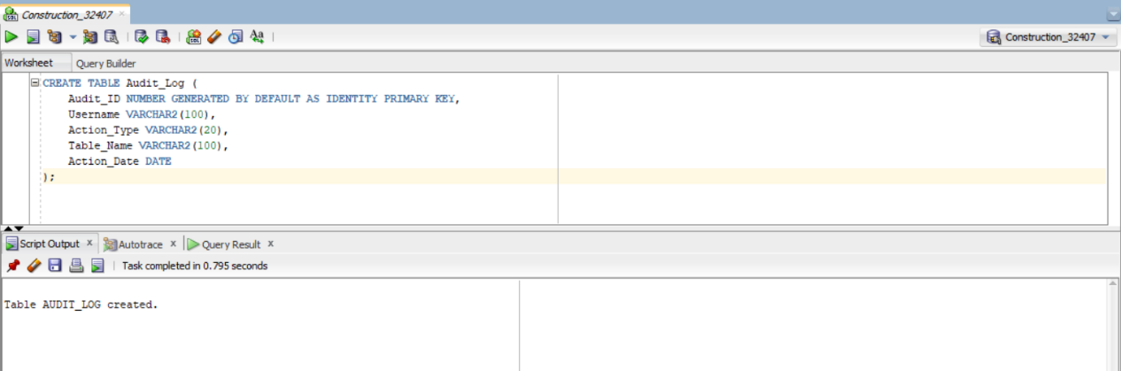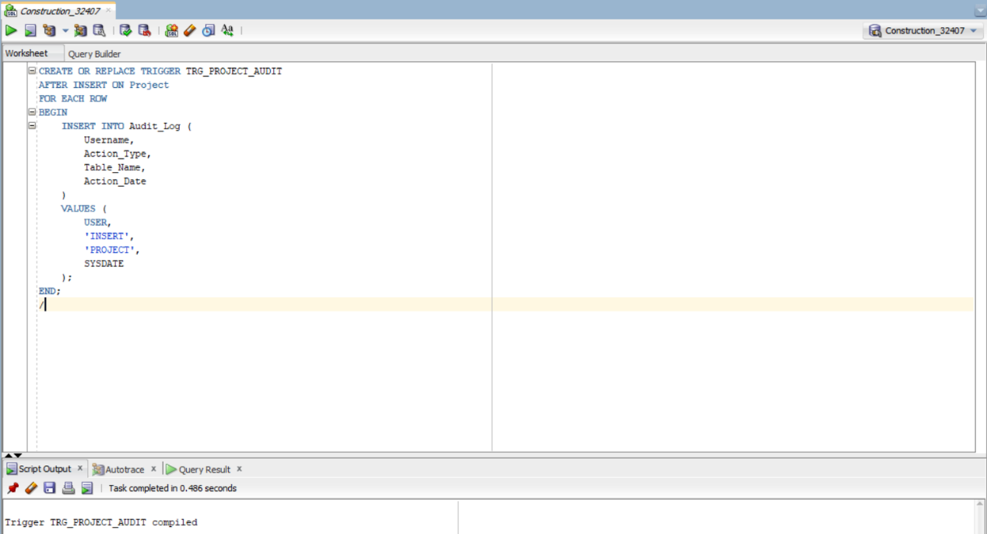
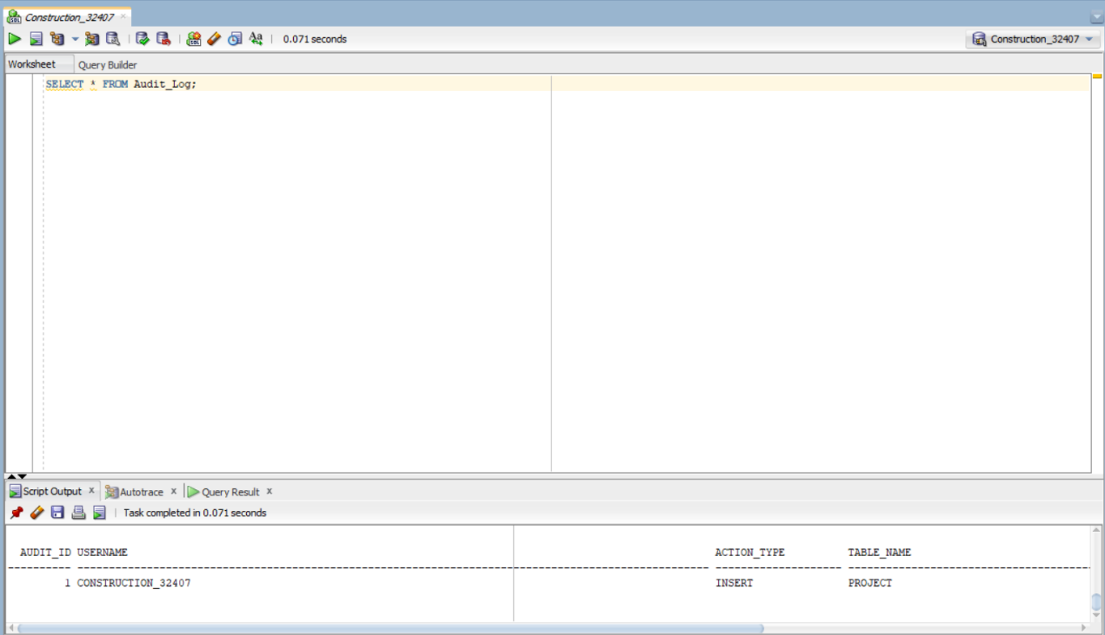
13.3 Simple Trigger
A simple trigger was implemented to monitor INSERT operations on the PROJECT table.
This trigger automatically records database activities in the audit table.
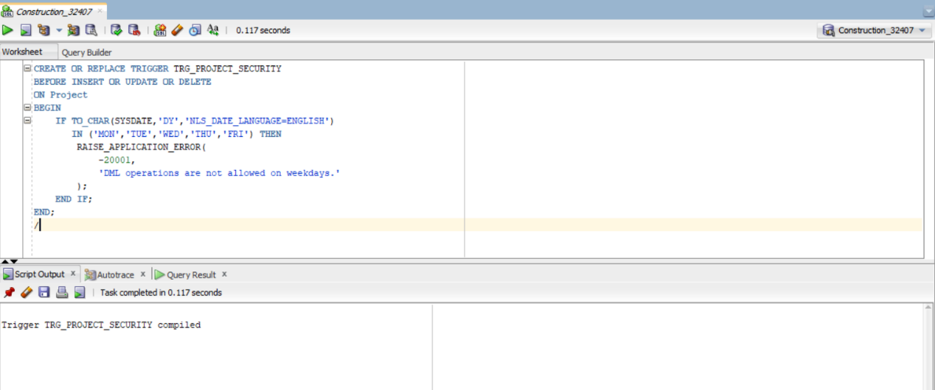
13.4 Compound Trigger
A compound trigger was implemented to demonstrate Oracle's advanced trigger functionality.
The trigger captures INSERT, UPDATE, and DELETE operations and displays execution messages using DBMS_OUTPUT.
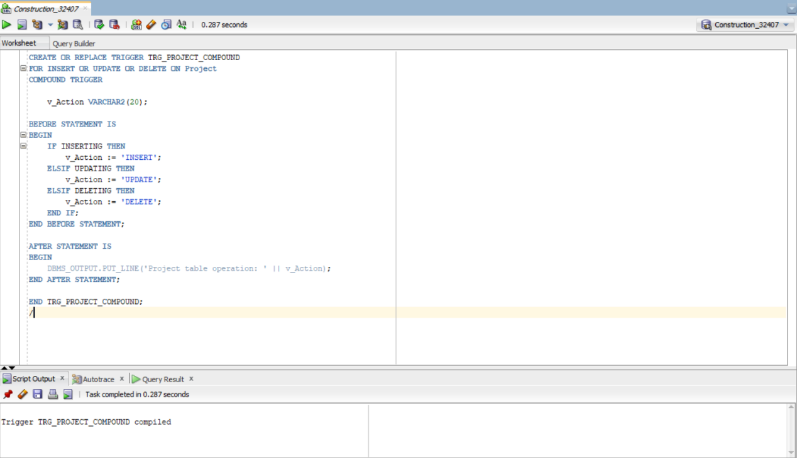
13.5 Security Trigger
A security trigger was implemented to enforce business rules.
The trigger blocks INSERT, UPDATE, and DELETE operations during:
- Monday to Friday
- Public holidays stored in the PUBLIC_HOLIDAYS table
This ensures that sensitive database modifications cannot be performed during restricted periods.
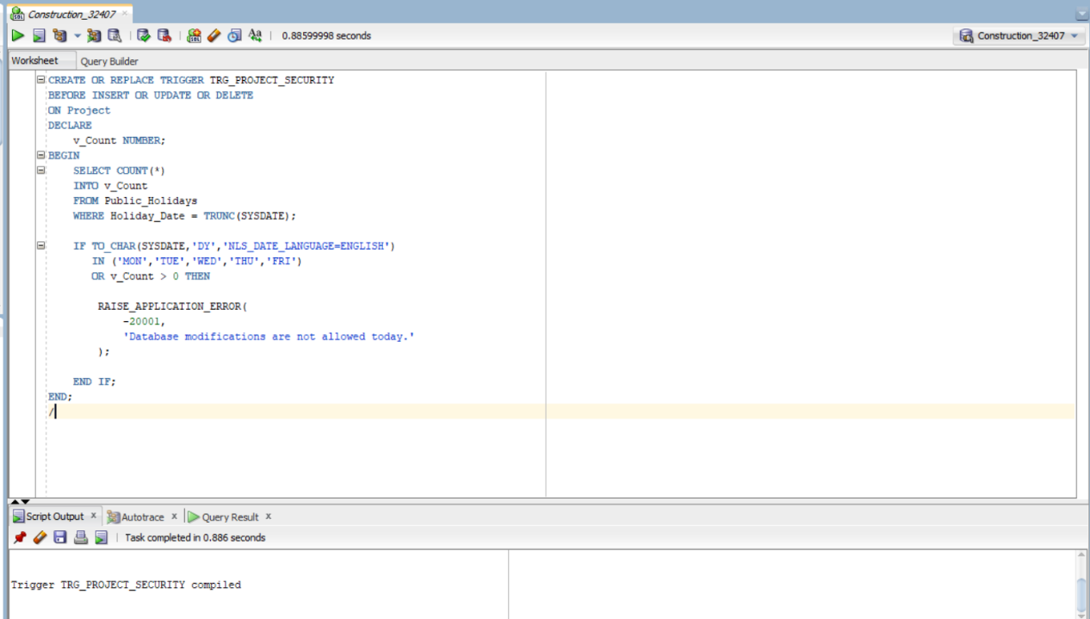
13.6 Database Objects
Finally, all Oracle database objects were reviewed to verify successful compilation.
All procedures, functions, packages, and triggers were compiled successfully and their status is VALID.
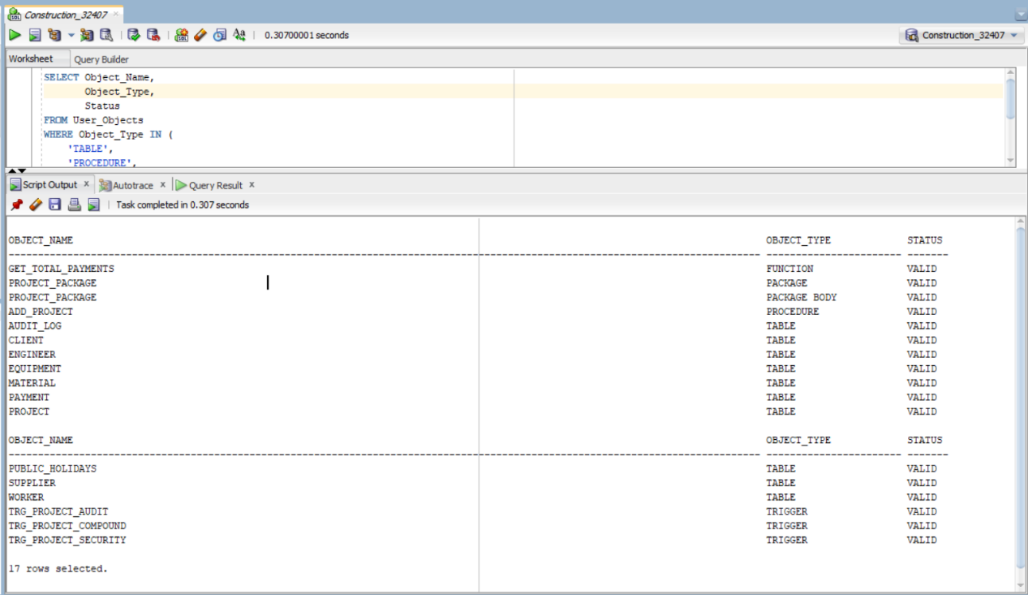

14. Innovation (Power BI Dashboard)
To enhance the functionality of the system beyond Oracle SQL and PL/SQL, Microsoft Power BI was integrated as the innovation component of the project. The dashboard provides a graphical representation of important project information and helps managers monitor project performance more efficiently.
The Power BI dashboard includes the following Key Performance Indicators (KPIs):
- Total Number of Projects
- Total Project Budget
- Total Payments
- Projects by Status
- Equipment Status
These visualizations provide quick insights into project performance and support better decision-making.
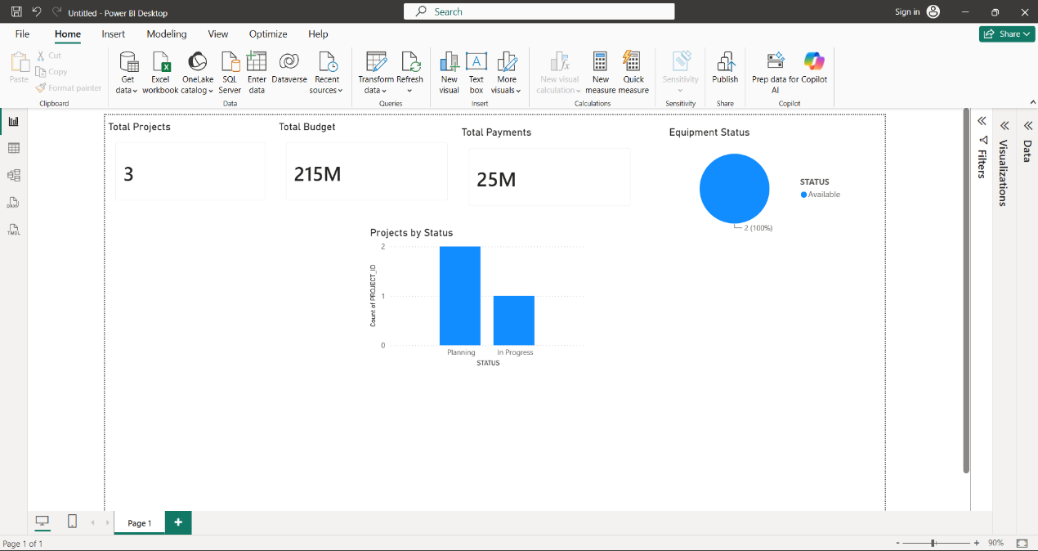

15. Testing Results
The system was tested successfully using Oracle SQL Developer.
The following components were verified:
Component | Status
Database Tables | ✅ Successfully Created
Constraints | ✅ Working Correctly
Sample Data | ✅ Inserted Successfully
SQL Queries | ✅ Executed Successfully
Stored Procedure | ✅ Tested Successfully
Function | ✅ Returned Correct Results
Package | ✅ Compiled Successfully
Cursor | ✅ Executed Successfully
Audit Trigger | ✅ Working Correctly
Compound Trigger | ✅ Working Correctly
Security Trigger | ✅ Business Rule Applied
Power BI Dashboard | ✅ Successfully Created

All Oracle database objects were compiled successfully and their status was VALID, confirming that the database implementation is complete and error-free.

16. Challenges Faced
During the development of this project, several challenges were encountered.
Some of the main challenges included:
- Understanding Oracle PL/SQL programming concepts.
- Designing relationships between database tables.
- Implementing triggers for auditing and security.
- Configuring Oracle SQL Developer.
- Connecting Oracle Database with Microsoft Power BI.
These challenges were overcome through testing, debugging, and continuous improvement of the database implementation.

17. Conclusion
The Construction Project Management System successfully demonstrates the use of Oracle SQL and PL/SQL to solve real-world database problems.
The project provides an integrated solution for managing construction projects, clients, engineers, workers, suppliers, materials, equipment, and payments.
Advanced Oracle programming concepts such as procedures, functions, packages, cursors, triggers, auditing, and security restrictions were successfully implemented.
In addition, Microsoft Power BI was integrated to provide interactive dashboards and project analytics, fulfilling the innovation requirement of the capstone project.
Overall, the project achieved all its objectives and demonstrates practical knowledge of Oracle Database Programming.

18. References
- Oracle Corporation. Oracle Database PL/SQL Language Reference. Oracle Documentation.
- Oracle Corporation. Oracle SQL Language Reference. Oracle Documentation.
- Microsoft. Power BI Documentation.
- Course Notes: DPR400210 – Database Programming with Oracle Database.

